Joshua 24: 1 - 2, 14 - 18

Then Joshua gathered all the tribes of Israel to Shechem, and summoned the elders, the heads, the judges, and the officers of Israel; and they presented themselves before God. And Joshua said to all the people, "Thus says the LORD, the God of Israel:

"Now therefore revere the LORD, and serve him in sincerity and in faithfulness; put away the gods that your ancestors served beyond the River and in Egypt, and serve the LORD. Now if you are unwilling to serve the LORD, choose this day whom you will serve, whether the gods your ancestors served in the region beyond the River or the gods of the Amorites in whose land you are living; but as for me and my household, we will serve the LORD."
Then the people answered, "Far be it from us that we should forsake the LORD to serve other gods; for it is the LORD our God who brought us and our ancestors up from the land of Egypt, out of the house of slavery, and who did those great signs in our sight. He protected us along all the way that we went, and among all the peoples through whom we passed; and the LORD drove out before us all the peoples, the Amorites who lived in the land. Therefore we also will serve the LORD, for he is our God."

Psalm 34: 1 - 2, 15 - 22

I will bless the LORD at all times;
his praise shall continually be in my mouth.
My soul makes its boast in the LORD;
let the humble hear and be glad.

The eyes of the LORD are on the righteous,
and his ears are open to their cry.
The face of the LORD is against evildoers,
to cut off the remembrance of them from the earth.
When the righteous cry for help, the LORD hears,
and rescues them from all their troubles.
The LORD is near to the brokenhearted,
and saves the crushed in spirit.
Many are the afflictions of the righteous,
but the LORD rescues them from them all.
He keeps all their bones;
not one of them will be broken.
Evil brings death to the wicked,
and those who hate the righteous will be condemned.
The LORD redeems the life of his servants;
none of those who take refuge in him will be condemned.

Ephesians 6:10-20
Finally, let the mighty strength of the Lord make you strong. Put on all the armor that God gives, so you can defend yourself against the devil’s tricks. We are not fighting against humans. We are fighting against forces and authorities and against rulers of darkness and powers in the spiritual world. So put on all the armor that God gives. Then when that evil day comes, you will be able to defend yourself. And when the battle is over, you will still be standing firm.
Be ready! Let the truth be like a belt around your waist, and let God’s justice protect you like armor. Your desire to tell the good news about peace should be like shoes on your feet. Let your faith be like a shield, and you will be able to stop all the flaming arrows of the evil one. Let God’s saving power be like a helmet, and for a sword use God’s message that comes from the Spirit.
Never stop praying, especially for others. Always pray by the power of the Spirit. Stay alert and keep praying for God’s people. Pray that I will be given the message to speak and that I may fearlessly explain the mystery about the good news. I was sent to do this work, and that’s the reason I am in jail. So pray that I will be brave and will speak as I should.

John 6:56-69

Whoever eats my flesh and drinks my blood remains in me, and I in them. Just as the living Father sent me and I live because of the Father, so the one who feeds on me will live because of me. This is the bread that came down from heaven. Your ancestors ate manna and died, but whoever feeds on this bread will live forever.” He said this while teaching in the synagogue in Capernaum.

On hearing it, many of his disciples said, “This is a hard teaching. Who can accept it?”

Aware that his disciples were grumbling about this, Jesus said to them, “Does this offend you? Then what if you see the Son of Man ascend to where he was before! The Spirit gives life; the flesh counts for nothing. The words I have spoken to you—they are full of the Spirit and life. Yet there are some of you who do not believe.” For Jesus had known from the beginning which of them did not believe and who would betray him. He went on to say, “This is why I told you that no one can come to me unless the Father has enabled them.”

From this time many of his disciples turned back and no longer followed him.

“You do not want to leave too, do you?” Jesus asked the Twelve.

Simon Peter answered him, “Lord, to whom shall we go? You have the words of eternal life. We have come to believe and to know that you are the Holy One of God.”

Take my yoke upon you…and you will find rest for your souls. Matt. 11:29

Life’s burdens are often made worse when we feel more alone with them than we need to. We always take on too much when we face ourselves or our circumstances on our own. We are meant, rather, to be yoked with Jesus as our first relationship, and then to all else secondly.

Whether it is to an action that needs to be done, or to a person or problem we are relating to, we assume more responsibility than necessary when we approach these things alone. Most Christians will naturally include God at some point in these relationships, but often only by implication. The focus too often remains primarily between ourselves and the thing we are relating to, with God more often on the periphery.

The diagram below depicts something of this relationship, when God is more in the background than should be (the dotted line being the implied relationship, and the solid line the direct one).
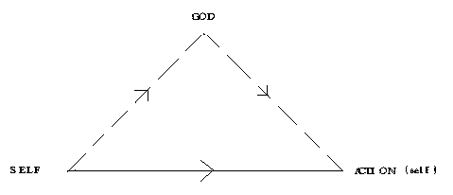
Scripture however would have us first be yoked with Jesus and then, together with Jesus, form a relationship to our action or to ourselves. No longer facing life alone, we then approach all things together with Christ. The following diagram illustrates this difference, where our primary relationship is to God and then, together with God, we address whatever else we face in life.

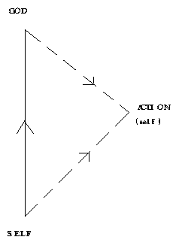
To always be mindful of God as our first recourse is a difficult posture to maintain. We keep returning to the more direct approach in our relationships, especially when the stakes or the demands of life seem high. We leave our primary bearings with God, and end up more yoked with our selves than with Christ.

It takes discipline to establish this truth as a constant in our lives. But there is no other way. We must choose between Jesus’ yoke or our curious preference for facing life alone. And, as Scripture promises, only the former can free us from the unnecessary burdens we will otherwise assume are ours

Rob Des Cotes
Imago Dei Christian Communities

